Final Report

Tim Vigers

03 December 2019

# Introduction

Basketball has come a long way since James Naismith threw a soccer ball through a peach basket. Webster’s dictionary defines basketball as…

# The Data

Total number of passes per season were manually downloaded from https://stats.nba.com/teams/passing/ and concatenated into a “long” dataset. These data were relatively well-organized to begin with and required minimal cleaning, but unfortunately only go back as far as 2013.

Traditional statistics, such as points, rebounds, etc. going back to the beginning of the NBA and ABA were downloaded using an HTML scraping tool developed for this project (see Appendix for code). These data were also relatively clean, but teams that moved or changed names were assigned a unique three letter code corresponding to their current location (e.g. observations from the New Orleans Jazz were given the code “UTA” in order to group them with the rest of the Jazz data). Also, seasons were designated using the numeric year of the first game of the season, (e.g. 2018 for the 2018-2019 season) in order to treat time as a continuous variable. There were no missing or excluded observations in these data, and counting statistics such as points, turnovers, etc. were converted to per-game measures in order to account for shortened seasons in 1998 and 2011. For these analyses I considered only data from after the ABA and NBA merger in 1976.

# Passing

## Mixed Model Selection

Prior to modeling the number of passes over time, I created a spaghetti plot with a line for each team (see Figure A1). There did not appear to be much of an overall trend. The total number of passes in a season appears to follow a normal distribution (Figure A2), so this outcome was modeled using a simple linear mixed model.

In order to test for a fixed effect of season on total number of passes made, I compared four linear mixed models. In the following models i indexes team, j indexes season, and x represents the season variable.

### Model 1: Random Intercept Only

### Model 2: Random Intercept and AR(1) Structure for Repeated Measures

### Models 3 & 4: Random Slope for Season

The last two models are the same as models 1 and 2, but with the addition of a random slope, so the random effects are:

with

The model with random intercept and random slope did not converge without the AR(1) structure for repeated measures, and the model with random intercept and AR(1) structure was the best by the Akaike information criterion (AIC) (Table A1).

Using loess smoothing to plot total number of passes made suggested a potential cubic trend in the data. So once the final model was selected, I also tested the polynomial effects of season up to a quadratic term:

## Piecewise Model

In addition to a linear mixed model, I also tried a linear spline model with a knot at 2015, including random intercept and AR(1) structure for repeated measures:

The year 2015 was chosen based on the estimated break point according to Muggeo’s method [1] and implemented using his R package “segmented” [2] (see Appendix for code).

## Results

### Table 1: The Effect of Time on Total Passes Made

|  |  |  |  |  |  |
| --- | --- | --- | --- | --- | --- |
|  | Value | Std.Error | DF | t-value | p-value |
| (Intercept) | 24349.989 | 235.835 | 146 | 103.250 | <1e-04 |
| Season | -40.362 | 2004.510 | 146 | -0.020 | 0.984 |
| Season^2 | -1941.549 | 1404.499 | 146 | -1.382 | 0.169 |
| Season^3 | 360.020 | 1088.741 | 146 | 0.331 | 0.741 |
| Season^4 | -465.829 | 925.730 | 146 | -0.503 | 0.616 |

According to the linear mixed model, passing has not changed significantly since 2013.

### Table 2: Change in Total Passes Made After the 2015 Season

|  |  |  |  |  |  |
| --- | --- | --- | --- | --- | --- |
|  | Value | Std.Error | DF | t-value | p-value |
| (Intercept) | 164836.019 | 213588.290 | 148 | 0.772 | 0.441 |
| Season | -69.854 | 106.029 | 148 | -0.659 | 0.511 |
| Change in Slope | 0.181 | 0.154 | 148 | 1.178 | 0.241 |

Passing appears to increase slightly after 2015 according to the linear spline model, but the change in slope is not statistically significant (p = 0.24).

# Assists

## Model Selection

Winning percentage appears to be reasonably normally distributed (Figure A3), so I used normal theory linear mixed models to determine whether increasing the percentage of baskets assisted results in more wins. Model selection for this question followed a similar process to the passing question. I compared models with random intercept for team to models with random intercept for team and random slope, both with and without an AR(1) structure for repeated measures. However, in these models the outcome was regular season win percentage and the fixed effects were percetange of baskets assisted (“AST%”); average team age (“Age”); average team height (“Ht.”); average team weight (“Wt.”); team field goal percentage (“FG%”); and steals (“SPG”), blocks (“BPG”), points (“PPG”), and turnovers (“TPG”) per game. Once again, the model with random intercept for team and AR(1) structure for repeated measures was the best by AIC (Table A2).

However, during model selection, I realized that there was a significant positive association between percentage of baskets assisted and winning percentage, but that this effect goes away when adjusting for field goal percentage (Table A3). So, I conducted a mediation analysis (see Appendix for code) to try and determine whether field goal percentage mediates the effect of assists on winning [2]. The “mediation” package in R requires models without the AR(1) structure for repeated measures, so the mediation analysis was conducted using only a random intercept for team.

## Results

### Table 3: The Effect of Assists per Game on Winning Percentage

Fixed Effects

|  |  |  |  |  |  |
| --- | --- | --- | --- | --- | --- |
|  | Value | Std.Error | DF | t-value | p-value |
| (Intercept) | -277.331 | 44.178 | 1110 | -6.278 | <1e-04 |
| AST% | 0.372 | 0.085 | 1110 | 4.397 | <1e-04 |
| Age | 3.878 | 0.222 | 1110 | 17.471 | <1e-04 |
| Ht. | 0.508 | 0.566 | 1110 | 0.898 | 0.369 |
| Wt. | 0.338 | 0.062 | 1110 | 5.440 | <1e-04 |
| SPG | 2.349 | 0.345 | 1110 | 6.804 | <1e-04 |
| BPG | 3.766 | 0.350 | 1110 | 10.763 | <1e-04 |
| TPG | -2.280 | 0.216 | 1110 | -10.568 | <1e-04 |
| PPG | 0.847 | 0.052 | 1110 | 16.396 | <1e-04 |

Without adjusting for FG%, increasing the number of baskets assisted by 10 percentage points can lead to a statistically significant (p = <1e-04) increase in winning of 3.72 percentage points on the season (or about 3.1 games). After adjustment for FG%, this effect is no longer significant (Table A3).

### Mediation Analysis

There is a significant (p < 0.0001) mediation effect of FG% on the relationship between AST% and winning percentage. Field goal percentage accounts for approximately 67.5% of the association, meaning that on average a 10 point increase in AST% directly results in closer to a 1.217 point increase in winning percentage (about 1 game) on the season.

# Discussion

Passing hasn’t changed, but assists help thorugh increasing FG%. Weird that height wasn’t a significant factor in winning.

# References

1. Muggeo, V.M.R. (2003) Estimating regression models with unknown break-points. Statistics in Medicine 22, 3055–3071.
2. Vito M. R. Muggeo (2008). segmented: an R Package to Fit Regression Models with Broken-Line Relationships. R News, 8/1, 20-25. URL <https://cran.r-project.org/doc/Rnews/>.
3. Tingley D, Yamamoto T, Hirose K, Keele L, Imai K. mediation: R package for causal mediation analysis. UCLA Stat Stat Assoc. August 2014. <https://dspace.mit.edu/handle/1721.1/91154>. Accessed December 2, 2019.

# Appendix

## Figure A1: Total Passes by Season

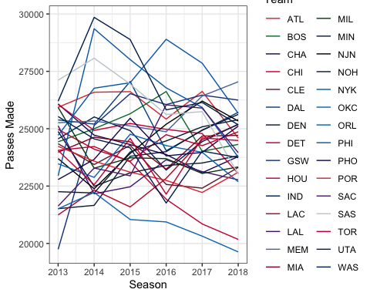

## Figure A2: Distribution of Total Passes

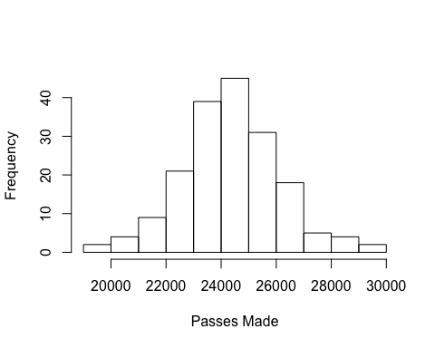

### Table A1: AIC of Passes Made Models

All models fit using ML estimation.

|  |  |  |
| --- | --- | --- |
|  | df | AIC |
| RI Only | 4 | 3159.781 |
| RI and AR(1) | 5 | 3120.225 |
| RI, RS, and AR(1) | 7 | 3124.225 |

## Figure A3: Distribution of Win Percentage

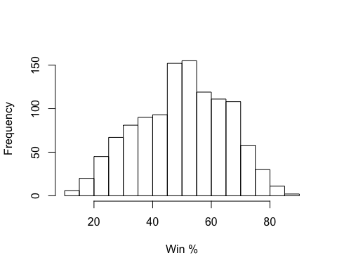

## Table A2: AIC of Win Percentage Models

All models fit using ML estimation.

|  |  |  |
| --- | --- | --- |
|  | df | AIC |
| RI Only | 12 | 8495.325 |
| RI and RS | 14 | 8499.289 |
| RI and AR(1) | 13 | 8264.485 |
| RI, RS, and AR(1) | 15 | 8268.486 |

## Table A3: Effect of Assists on Win Percentage, Adjusted for FG%

Fixed Effects

|  |  |  |  |  |  |
| --- | --- | --- | --- | --- | --- |
|  | Value | Std.Error | DF | t-value | p-value |
| (Intercept) | -288.599 | 40.557 | 1109 | -7.116 | <1e-04 |
| AST% | 0.122 | 0.079 | 1109 | 1.530 | 0.126 |
| Age | 3.203 | 0.209 | 1109 | 15.331 | <1e-04 |
| Ht. | -0.195 | 0.521 | 1109 | -0.373 | 0.709 |
| Wt. | 0.436 | 0.058 | 1109 | 7.588 | <1e-04 |
| SPG | 2.937 | 0.319 | 1109 | 9.192 | <1e-04 |
| BPG | 3.447 | 0.322 | 1109 | 10.707 | <1e-04 |
| TPG | -2.983 | 0.204 | 1109 | -14.635 | <1e-04 |
| PPG | 0.099 | 0.070 | 1109 | 1.427 | 0.154 |
| FG% | 351.702 | 24.059 | 1109 | 14.618 | <1e-04 |

## Figure A4: Mediation Diagram

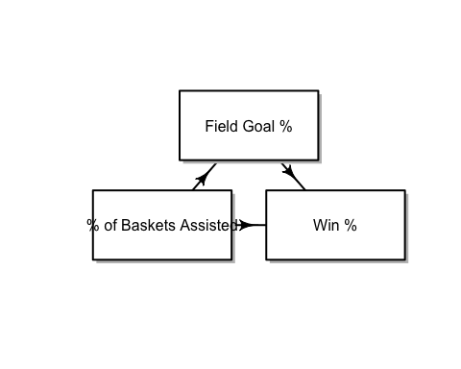

## Code

### HTML Scraping Tool

library(rvest)  
library(tidyverse)  
teams <- c("ATL","BOS","NJN","CHA","CHI","CLE","DAL","DEN","DET","GSW","HOU",  
 "IND","LAC","LAL","MEM","MIA","MIL","MIN","NOH","NYK","OKC","ORL",  
 "PHI","PHO","POR","SAC","SAS","TOR","UTA","WAS")  
# Scrape each team page  
all_seasons <- data.frame()  
for (team in teams) {  
 url <- paste0("https://www.basketball-reference.com/teams/",team,"/stats_basic_totals.html")  
 table <- url %>%  
 read_html() %>%  
 html_nodes("table") %>%  
 html_table()  
 df <- as.data.frame(table[[1]])   
 df <- df[colnames(df) != ""] %>%  
 filter(Season != "Season",Season != "2019-20")  
 df[df == ""] <- NA  
 df <- as.data.frame(lapply(df, as.character))  
 colnames(df) <- c("Season","Lg","Tm","W","L","Finish","Age","Ht.","Wt.",  
 "G","MP","FG","FGA","FG%","3P","3PA",  
 "3P%","2P","2PA","2P%","FT","FTA","FT%","ORB","DRB","TRB",  
 "AST","STL","BLK","TOV","PF","PTS")  
 df$Team <- team  
 all_seasons <- rbind.data.frame(all_seasons,df)  
}

### Break Point

linmod <- lm(Passes.Made ~ Season,data = passing)  
segmented(linmod)

## Call: segmented.lm(obj = linmod)  
##   
## Meaningful coefficients of the linear terms:  
## (Intercept) Season U1.Season   
## -547034.4 283.7 -421.6   
##   
## Estimated Break-Point(s):  
## psi1.Season   
## 2015

### Mediation

# Mediation with FGP as mediator  
mod.y <- lmer(w_perc ~ AST_perc + Age + Ht. + Wt. + STL_game + BLK_game + TOV_game +   
 PTS_game + FGP + (1|Team),data = post_merger)  
mod.m <- lmer(FGP ~ AST_perc + Age + Ht. + Wt. + STL_game + BLK_game + TOV_game +   
 PTS_game + (1|Team),data = post_merger)  
med_fgp <- mediate(mod.m,mod.y,treat = "AST_perc",mediator = "FGP")  
# Mediation with AST as mediator  
mod.m <- lmer(AST_perc ~ FGP + Age + Ht. + Wt. + STL_game + BLK_game + TOV_game +   
 PTS_game + (1|Team),data = post_merger)  
med_ast <- mediate(mod.m,mod.y,treat = "FGP",mediator = "AST_perc")  
# Mediation summary  
summary(med_fgp)

##   
## Causal Mediation Analysis   
##   
## Quasi-Bayesian Confidence Intervals  
##   
## Mediator Groups: Team   
##   
## Outcome Groups: Team   
##   
## Output Based on Overall Averages Across Groups   
##   
## Estimate 95% CI Lower 95% CI Upper p-value   
## ACME 0.2514 0.1809 0.33 <2e-16 ***  
## ADE 0.1219 -0.0305 0.28 0.13   
## Total Effect 0.3733 0.2106 0.54 <2e-16 ***  
## Prop. Mediated 0.6747 0.4515 1.12 <2e-16 ***  
## ---  
## Signif. codes: 0 '***' 0.001 '**' 0.01 '*' 0.05 '.' 0.1 ' ' 1  
##   
## Sample Size Used: 1148   
##   
##   
## Simulations: 1000

summary(med_ast)

##   
## Causal Mediation Analysis   
##   
## Quasi-Bayesian Confidence Intervals  
##   
## Mediator Groups: Team   
##   
## Outcome Groups: Team   
##   
## Output Based on Overall Averages Across Groups   
##   
## Estimate 95% CI Lower 95% CI Upper p-value   
## ACME 7.94980 -2.15036 18.91 0.13   
## ADE 352.03485 305.92526 401.18 <2e-16 ***  
## Total Effect 359.98466 314.24555 404.83 <2e-16 ***  
## Prop. Mediated 0.02125 -0.00603 0.05 0.13   
## ---  
## Signif. codes: 0 '***' 0.001 '**' 0.01 '*' 0.05 '.' 0.1 ' ' 1  
##   
## Sample Size Used: 1148   
##   
##   
## Simulations: 1000